**Overview**

The adult drug court data improvement project, a partnership between Washington’s adult felony drug courts and the Washington State Center for Court Research (WSCCR), collects and reports statewide information that policy makers, judicial leadership and local court managers can use. Its focus is to collect basic information about drug court participants and process into a data repository that can provide information essential to understanding the extent to which our drug courts fulfill their mission.

The use of data for program improvement is an established evidence-based best practice, demonstrated for drug courts and in other arenas.[1] Courts and other organizations produce better outcomes when they use data to make decisions. NPC Research, a leading organization studying therapeutic courts, has found use of data to be the number one best practice for generating cost savings.[2] NPC stated: “*Drug Courts where internal review of the data and program statistics led to modifications in program operations had 131% higher cost savings.”*[3] Similarly, NPC found an 85% reduction in recidivism.[4]

**Updated Results**

The project did not attempt to compile a historical record going back to the establishment of the drug courts. Instead the data collection and database includes participants starting drug court on January 1, 2012 and after. This 2015 report is a simple snapshot of participant status at the end of 2014 for those starting drug court in 2012, 2013 and 2014. No participants admitted before January 1, 2012 or after December 31, 2014 are included; no events occurring after December 31, 2014 are included. For this report, we received data from all 23 jurisdictions with adult drug courts.

Because many of the drug court programs take up to 2 years, many participants starting in 2013 and 2014 were still in their programs on December 31, 2014. Therefore, at this point we cannot compute accurate, meaningful statewide graduation and termination rates. We can, however, compute retention rates as of the end of 2014. The retention rate is the percentage of drug court participants who are currently active or have graduated for a specified cohort of participants entering the program, such as the cohort who entered programs in 2012. Retention is an indicator of how well drug court programs engage participants and sustain their participation, and “is an important predictor of positive long-term outcomes, such as reduced recidivism and drug use.”[5] Retention rates are affected by many variables including admissions criteria and policies, the treatment and substance abuse testing programs employed, the effectiveness of the drug court’s process, and the composition of the drug court team.

We calculated 6 and 18 month retention rates for those admitted in 2012 in the 23 Washington courts. These rates varied widely. For the retention calculations in this report, anyone who had an active bench warrant at the end of the reporting interval is included in the “Active” category.[6]

We also calculated retention rates for those admitted in each of the 23 courts.

* Courts with fewer than 10 admissions in 2012

**Drug Court Admissions and Superior Court Case Filings:** Because the vast majority of drug court participants have been charged with substance abuse related offenses, comparing admissions to the number of defendants charged during the year with such offenses provides some indication of how well drug courts are meeting the need. This table shows the results for the three year period:

|  |  |  |  |
| --- | --- | --- | --- |
|  | 2012 | 2013 | 2014 |
| Participants starting drug court | 1,498 | 1,384 | 1,544 |
| Defendants - cases filed with drug charges | 9,526 | 9,449 | 9,374 |
|  | 16% | 15% | 16% |

It should be noted that it is unknown how many of these defendants were not statutorily eligible for drug court or would not have been admitted because of other factors such as determinations that they were not drug dependent or substance abusers.

**Participants Admitted in 2014**: Statewide, 1,544 participants started drug court in **2014**. The retention rate at the end of 2014 for the cohort of 2014 admits was 68%. The retention rate includes as active the 12.4% who had outstanding bench warrants at the end of 2014 in addition to those who graduated on or before December 31, 2014 and those active on that date. It is too soon to report other meaningful numbers on those admitted in 2014.

Distribution of Participants Admitted in 2014 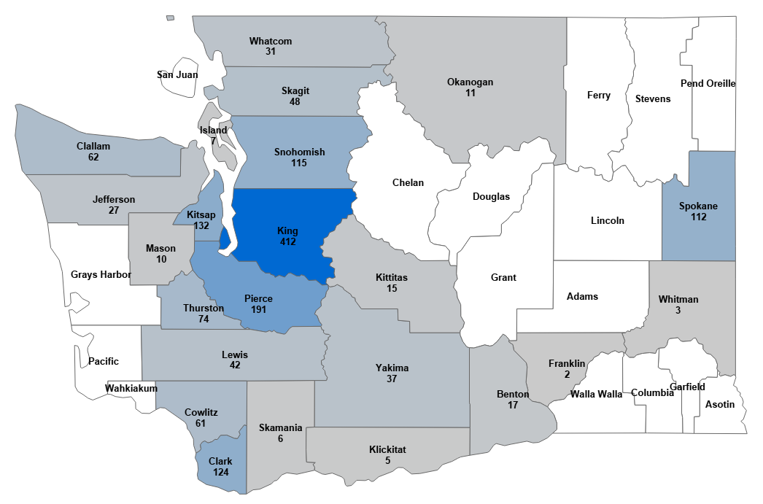

(White counties do not have adult drug courts.)

**Participants Admitted in 2013**: At the end of 2014 the status of the 1,384 participants starting drug court in **2013** was:

|  |  |  |
| --- | --- | --- |
| Participants Started | 1,384 | 100.0% |
| Opted-Out | 177 | 12.8% |
| Admission Denied | 3 | 0.2% |
| Withdrew (after expiration of any opt-in or opt-out period) | 31 | 2.2% |
| Terminated | 414 | 29.9% |
| Deceased | 5 | 0.4% |
| Graduated | 238 | 17.2% |
| Bench Warrant Outstanding on 12/31/2014 | 61 | 4.4% |
| Active (& no active bench warrant) on 12/31/2014 | 455 | 32.9% |

23 of 23 jurisdictions reporting

Based on these numbers the retention rate at the end of 2014 for the cohort of 2013 admits was 54%. The retention rate includes as active the 4.4% who had outstanding bench warrants at the end of 2014 in addition to those who graduated on or before December 31, 2014 and those active on that date.

**Participants Admitted in 2012**:At the end of 2014 the status of the 1,498 participants starting drug court in **2012** was:

|  |  |  |
| --- | --- | --- |
| Participants Started | 1,497 | 100.0% |
| Opted-Out | 247 | 16.5% |
| Admission Denied | 7 | 0.5% |
| Withdrew (after expiration of any opt-in or opt-out period) | 42 | 2.8% |
| Terminated | 474 | 31.7% |
| Deceased | 2 | 0.1% |
| Graduated | 528 | 35.3% |
| Bench Warrant Outstanding on 12/31/2014 | 29 | 1.9% |
| Active (& no active bench warrant) on 12/31/2014 | 168 | 11.2% |

23 of 23 jurisdictions reporting

Based on these numbers the retention rate at the end of 2014 for the cohort of 2012 admits was 48%. The retention rate includes as active the 1.9% who had outstanding bench warrants at the end of 2014 in addition to those who graduated on or before December 31, 2014 and those active on that date.

As additional annual data is added, a clearer picture of each year’s activity and year-to-year changes will emerge. Future reports will also present snapshots, but over time, as participants move through drug court, we will be able to compute meaningful statewide admission, termination and graduation rates. Trends and significant changes will become visible.

**DEFINITIONS**

**Participants Started** means the participant started the program including therapy, substance abuse monitoring, and attending review hearings. At this point most participants will have signed a contract in the form of a Waiver (of the right to trial by jury if the drug court admits participants prior to adjudication) and Agreement. If the court’s process also requires that the participant opt-in, Participants Started includes only those who have opted-in.

**Opted-Out** means the participant started the program, but under the local court’s policies later opted-out of it. These policies typically permit the participant to opt-out within a limited period of time after starting and without the loss of rights stipulated to in the Waiver and Agreement.

**Admission Denied** means the court permitted the participant to start the program on a trial basis, and later, based on observation of the participant, decided to deny formal admission and to end participation.

**Withdrew** means the participant voluntarily withdrew from the program after starting and after any opt-out period.

* If the court does not have a formal opt-in or opt-out period, indicates that participant voluntarily withdrew after starting the program.
* If the court does have a formal opt-in or opt-out period, indicates that the participant voluntarily withdrew after opting-in or after the expiration of the opt-out period.

Applies only if the court allows participants to voluntarily withdraw from the program regardless of any provision to opt-in or opt-out.

**Terminated** means the court formally terminated the participant from the program. The decision to terminate can be based on the participant’s failure to comply with drug court requirements or on the participant’s failure in the treatment program. A participant who is terminated is subject to the loss of rights stipulated to in the Waiver and Agreement.

**Graduated** means the participant completed the program’s requirements. Typically there is a graduation ceremony which, in the case of a pre-adjudication court, includes the judge signing the court order dismissing the charges.

**Deceased** means the participant died while an active participant in the program.

**Bench Warrant Outstanding** means the participant failed to meet program requirements and the court issued a bench warrant which was active at the end of the reporting period. Most bench warrants are issued when a participant fails to appear at a review hearing.

**Active** means the participant was active at the end of the reporting period. If the participant had an outstanding bench warrant on that date, the participant is not counted as active.

**How Statewide Drug Court Data Can Be Used**

Policy Makers: Policy makers will get a comprehensive, state-level picture of activity in the drug courts. They will know how many people the courts are serving across the state. They will be able to see how Washington’s experience compares with other states by comparing our data with other available data.

Judicial Leadership: Judicial leaders at the state level will also benefit from a statewide view that can be used for decision making.

Local Courts: In each jurisdiction, judicial leadership and court management will know how their court compares with statewide results and with non-Washington jurisdictions.

**Background: Data Improvement Project**

BJA & SCJA:The project began with a December 2011 request from the Superior Court Judges’ Association (SCJA) to WSCCR for a statewide view of participation in adult drug courts including a process for statewide data collection, appropriate analysis of the data collected, and reporting. In response, a basic data collection process has been created.

The data project also responds to the Board for Judicial Administration (BJA) 2012 resolution voicing support for drug courts. The resolution called for identification and adoption of best practices in drug courts, collection of data to evaluate and monitor outcomes and performance, and training for judicial officers and staff on the principles and methods of drug courts.

Objectives:To meet the goals of providing useful information to the courts and policy makers, the objectives for the data improvement project include:

1. Create a statewide data repository containing basic data on adult drug court cases.
2. Enable reporting to each adult felony drug court in Washington on its:

* Number of participants entering drug courts.
* Number of active participants.
* Number failing to complete drug court.
* Number graduating.
* Average length of time to graduation, withdrawal or termination from the program.

1. Provide statewide totals for each category.
2. Facilitate future analysis including statewide level reporting on recidivism of participants by age, gender and race.

**Background: Adult Drug Courts and Other Therapeutic Courts**

Therapeutic courts in Washington now have a twenty year history beginning with the creation of the adult drug court in King County in 1994. Now there are 83 therapeutic courts of various types including adult (felony), juvenile, family treatment, DUI, DV and veterans courts in 26 of the state’s 39 counties representing 96% of the state’s population. Adult drug courts are present in 23 counties representing 93% of the state’s population. At the end of 2014 their statewide enrollment was 1662 participants.

Washington’s adult drug courts generally conform to the traditional drug court model in which:

* The participant undergoes substance abuse treatment for an extended period of time (usually one to two years).
* The court monitors the participant’s progress.
* The participant is required to submit to a urinalysis on a frequent, random schedule.
* The court periodically (at appropriately frequent intervals) conducts a hearing in which the participant’s progress is reviewed, and the participant and the judge discuss the participant’s status.
* The court imposes sanctions for the participant’s non-compliance with program requirements, and provides rewards for compliance and progress.
* The participant may be terminated from the program, and returned to the trial court for further proceedings, if violations of program requirements merit.
* The court conducts a formal graduation ceremony for participants who successfully complete the program.
* The court uses a multi-disciplinary team including the judge, prosecutor, defender, law enforcement, treatment provider, case manager, drug court coordinator and others who routinely participate in team meetings and review hearings.

Though the majority use a pre-disposition approach in which charges are dismissed if the participant successfully completes the program, some courts are post-disposition where sentencing is stayed and generally, if there is successful completion, either jail time and fines are waived or, in some counties, charges are dismissed. In addition, the courts differ from county to county in terms of process and criteria for admission, court process, use of sanctions and incentives, treatment, and graduation requirements. As noted below, the data improvement project attempts to deal with these differences through the use of standard data definitions, understanding the different court processes, and identifying for reporting and collection purposes data points (such as participant start date) that can be used consistently with all courts.

A schematic of the drug court process is in Appendix A.

**2015 Data Collection**

Method and Process: This year WSCCR partnered with the Washington State Department of Social and Health Services Research and Data Analysis Division (RDA) to collect adult drug court data. The objectives of this partnership are to avoid duplicate requests and thereby reduce the administrative burden on courts, to further uniformity in data collection, and to streamline the collection process for both agencies. RDA administers collection of the data on behalf of WSCCR so that courts need only provide one data set that both agencies can use.

Previously courts had provided data to both RDA and WSCCR in response to their independent requests for data.  Last summer RDA and WSCCR, with the participation of a group of drug court coordinators, negotiated the basis for a joint request.  The intent is to do a single annual request.  This arrangement was approved by the Superior Court Judges’ Association Board and is governed by a data sharing agreement between the two agencies.

In March 2015 RDA sent a request for 2014 calendar year data to the 23 adult drug courts. All 23 adult drug courts responded with data. The request uses the standard set of data definitions developed in 2013 with input from a representative group of drug court coordinators. In addition, at the request of RDA the participant’s name, gender, ethnicity and date of birth were added this year. These standard definitions will make possible an accurate and consistent statewide drug court database as the project collects future years’ data and assimilates it into the database. The data collection instrument was an Excel spreadsheet.

The data elements include the Superior Court Management Information System (SCOMIS) case number which permits linking the data to the statewide Judicial Information System criminal history database for calculation and reporting of recidivism at some point in the future. The additional data elements this year and SCOMIS number also will facilitate future reporting on participants by age, gender and race.

Data Assimilation: Assembling the data was complicated because the local courts used a variety of sources to extract their data. These include:

* The Drug Court Case Management System (DCCM) is a commercial web-based software produced by Advanced Computer Technologies and used by nine courts. WSCCR was able to export data for these nine courts directly from its database.
* Unique locally developed databases use database software such as Microsoft Access.
* Locally maintained off-the shelf software from Loryx Systems is used in two counties.
* Local case files include paper records, optically imaged records and Word documents.
* The Superior Court Management Information System (SCOMIS) which the Administrative Office of the Courts maintains. Because drug court data is not entered into SCOMIS in a consistent manner across the state, it is generally not usable to report on drug court cases. However, for one court, where drug court data appeared to be complete, SCOMIS was used.

|  |  |
| --- | --- |
| **Database Type** | **# of Courts** |
| DCCM | 9 |
| Unique locally developed database | 7 |
| Locally maintained off-the shelf software | 2 |
| Local case files | 4 |
| SCOMIS and local court database | 1 |
| Total courts providing data | 23 |

After WSCCR received the courts’ data, the next step was to assemble it into a database form that was consistent across all courts. The issues dealt with in this phase include:

* Record keeping and local court database capabilities are limited and vary from court to court. None of the courts were able to provide all of the data elements requested. All courts did provide sufficient data to calculate numbers of participants starting their programs, terminated and graduated in 2012, 2013 and 2014.
* Drug court processes vary from court to court. To deal with this the project identified data points that were consistent, as much as possible, from court to court. To understand the differences and how they fit with the drug court model, the AOC therapeutic court team including the WSCCR researcher visited courts to observe procedures and meet with drug court coordinators, judges and other members of drug court teams.

Processes vary particularly with respect to program admission. To mark when a participant entered a program, we tried to identify a participation start date, rather than the formal admission date. A formal admission event in which the participant signs a contract is not necessarily in step with starting the program of treatment, periodic substance abuse testing, and monitoring by the court. Some courts use an opt-in approach where the participant may start treatment, but does not start drug court until formally opting in. Others have a period after the contract is signed in which the participant can opt out and return to the trial court with no contractual obligations. Others have neither opt-in nor opt-out periods.

* Some of the data provided were in raw extract form and had to be converted to the uniform statewide Excel format.

**Future Development**

The next steps, planned for 2016, for data improvement include:

1. Build a data repository that the courts and AOC can use to obtain information on the adult drug courts. Continue to implement the standard set of data (based on standard data definitions) for each court.
2. Provide feedback to the local courts. Use AOC feedback and local court review to support data improvement. The feedback will cover the validity and usefulness of the data. The AOC will also provide assistance to the courts in order to improve the quality of their data.
3. Based on what was learned in 2015, work with RDA to set up and implement the 2016 data collection; provide technical assistance to courts that need help with data extracts.
4. Develop 2016 reports; as the available data grows to the point where more meaningful information can be provided, continue to move to a standard annual report on activity in adult drug courts.
5. Based on user feedback, policy makers’ needs and national standards, refine and enhance reports. Add reports that breakdown participants by age, gender, race and ethnicity.

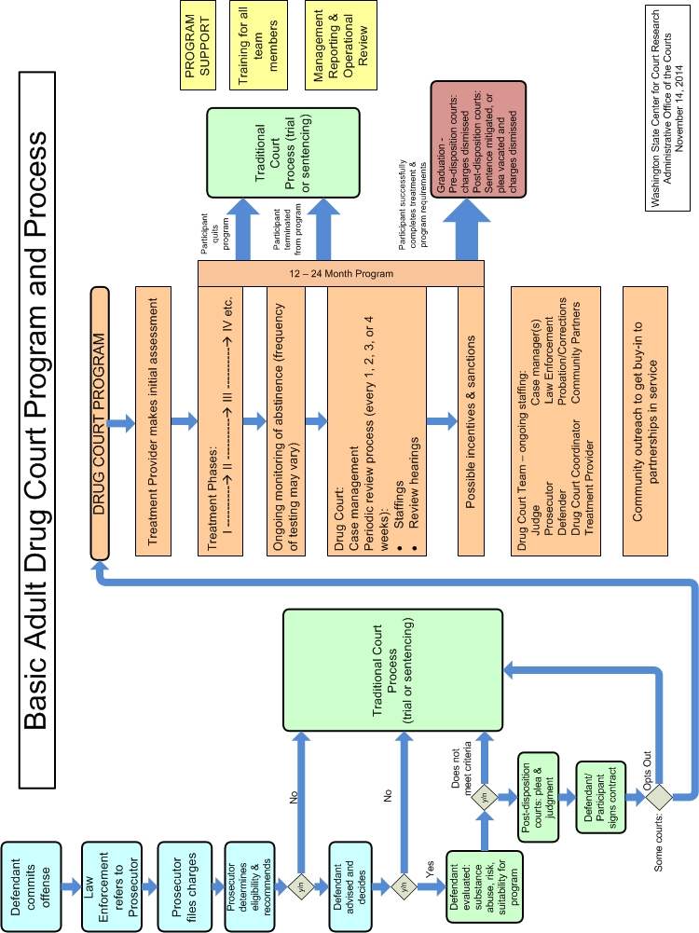

1. Kroll, A. Exploring the Link between Performance Information Use and Organizational Performance: A Contingency Approach. forthcoming in *Public Performance & Management Review* (2014) (<https://www.lafollette.wisc.edu/images/publications/PIP/Kroll_2014_PPMR.pdf>, accessed November 19, 2014).
2. Carey, S. M., Mackin, J. R., & Finigan, M. W.: What Works? The Ten Key Components of Drug Court: Research-Based Best Practices. *Drug Court Review* (2012), 8:1, 6-42 (<http://www.npcresearch.com/Files/Best_practices_in_drug_courts_2012.pdf>, accessed November 19, 2014).
3. Ibid., 27.
4. Ibid., 26.
5. Rossman, Shelli B., John K. Roman, Janine M. Zweig, Michael Rempel, and Christine H. Lindquist. Multi-Site Adult Drug Court Evaluation (MADCE), 2003-2009, 3:101.
6. Data on whether a participant had an active bench warrant at 6 or 18 months were not available. Data on whether a participant had a bench warrant at the end of 2014 were available and are reported below. Since many participants with bench warrants are terminated after they are brought into custody or otherwise do not continue the drug court program, the actual retention rates are likely inflated. However, because other participants with bench warrants continue their programs after they are taken into custody, not including them as active would understate the retention rate. The inability to distinguish which cases have bench warrants means the operational definition of active here is different from the definition of active on page 6.